Name: | ___________________________________________________ |  |  | Date: ___________
 | Year 9 Mathematics  Test 2, 2015  Topics – Pythagoras and Area |  |  | 
Total Time: | 60 minutes | 56  = %
Total Reading: | 5 minutes
Total Working: | 55 minutes
Weighting: | ______% of the year.
SECTION 1: CALCULATOR FREE
Time: | 17 minutes | Marks for Section 1: | 15
Reading: | 2 minutes | Equipment Allowed: | Nil
Working: | 15 minutes

1. | [3 marks: ½, ½, ½, ½, ½, ½ ]
 | Complete the following sentences using the words or expressions below. Note that you may not need to use all the words:
area circle diagram hypotenuse
length perimeter right angle
square units volume
a) | The longest side of a right-angled triangle is called the _______________________________.
b) | The hypotenuse is always situated opposite the _______________________________.
c) | When using Pythagoras’ theorem, always check the _______________________________ given for each measurement.
d) | The _______________________________ of a shape is a measure of the amount of surface enclosed by the shape.
e) | The _______________________________ of a shape is the distance around the outside of a shape.
f) | π is used to calculate the perimeter and area of a _______________________________.
2. | [1 mark]  Circle the correct answer
 | Which of the following statements is true for the given diagram?
 | 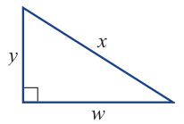 | A y² – w² = x² B x² – w² = y²  C y² – x² = w² D w² – x² = y²  E w² – y² = x²

3. |  | [2 Marks: 1, 1]  Circle the correct answer:
a) |  | The unit of measurement that would be most appropriate to measure the length of your table would be:  A) mm B) mm² C) cm D) cm²
b) |  | The unit of measurement that would be most appropriate to measure the area of the school oval would be:  A) cm B) cm² C) m D) m²
 | 4. |  | [4 marks: 1, 1, 1, 1]
 |  |  | Determine the perimeter of the following shapes:
 | a) |  | 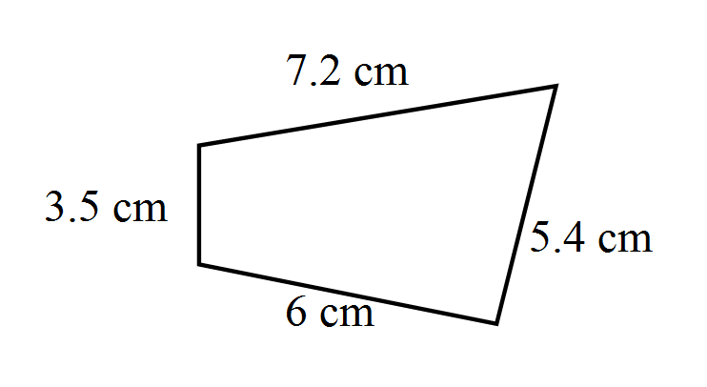 | b) | 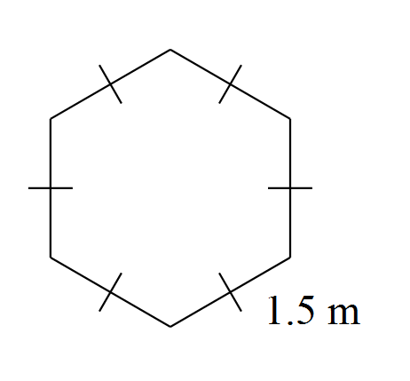
 | c) |  | 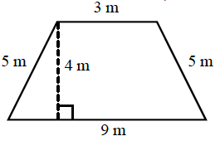 | d) | 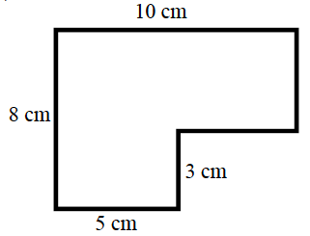
 | 5. |  | [4 marks: 1, 1, 1, 1]
 |  |  | Determine the area of the following shapes:
 | a) |  | 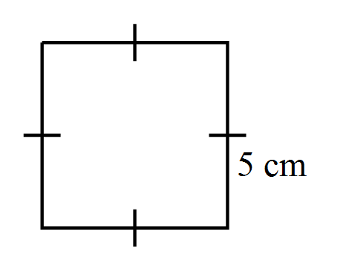 | b) | 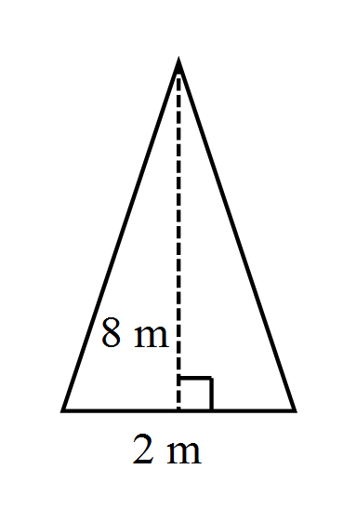
 | c) |  | 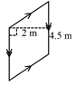 | d) | 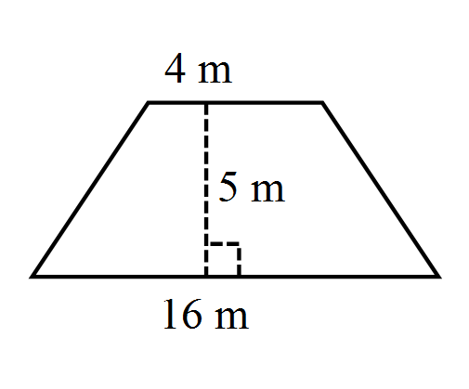

6. | [1 Mark]  Find the length of the missing dimension ‘x’.  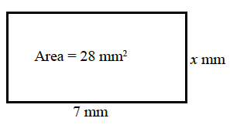

~ END OF TEST SECTION 1 ~

Name: | ___________________________________________________ |  |  | Date: ___________
SECTION 2: CALCULATOR ASSUMED
Time: | 44 minutes | Marks for Section 2: | 41
Reading: | 3 minutes | Equipment Allowed: | ½ page notes (A4 one side), Scientific calculator
Working: | 41 minutes

7. | [8 marks: 2, 2, 2, 2]
 | Calculate the length of the unknown side in each of the following triangles, give answers to 2 decimal places where appropriate.
a) | 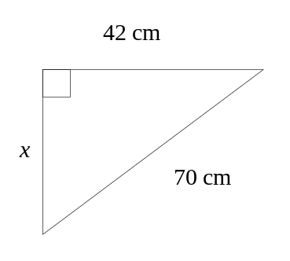 | b) | 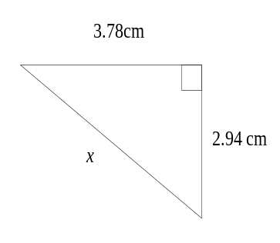
c) | 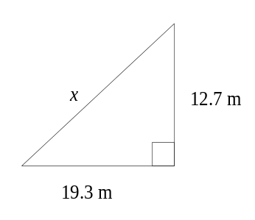 | d) | 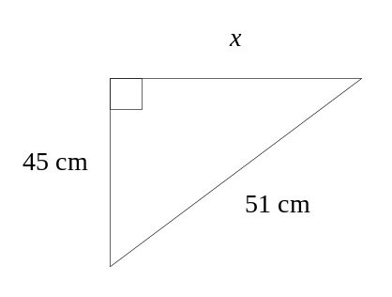

8. | [8 marks: 5, 3]
a) | A 12m tall pole is supported by two wires attached to the top of the pole. The two wires are anchored to the ground one on either side of the pole. One wire is 6.5m from the base of the pole, the other is 10m from the base of the pole.  a) Sketch a diagram of the situation  b) What is the total length of the wires?
b) | Two buildings are directly opposite one another, either side of a 15m wide street. One building is 25m tall the other is 40m tall.  a) Sketch a diagram of the situation.  b) What is the diagonal distance between the top of the two buildings?

9. | [2 marks: 1, 1]
 | Determine whether the following are Pythagorean triples:
a) | 5, 8, 13 | b) | 7, 9, 11

10. |  | [5 marks: 2, 3]
 |  | Determine the area of the following shapes:
a) |  | 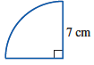 | b) | 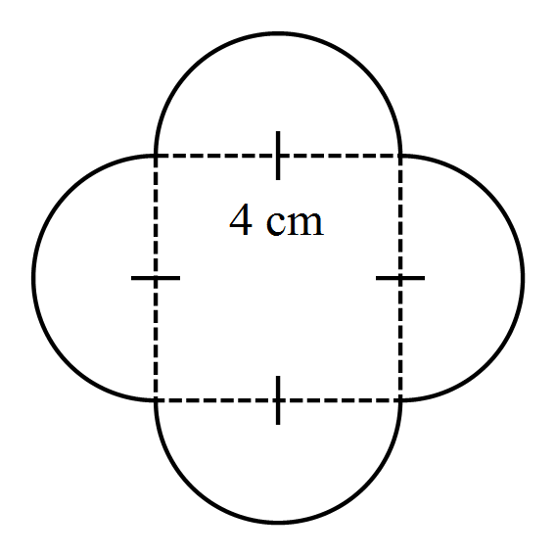
11. |  | [4 marks: 2, 2]
 |  | Find the area of each shape – expressed in cm²
a) |  | 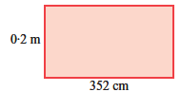 | b) | 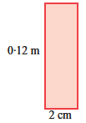

12. | [5 marks: 2, 3]
 | Find the area of each shape
a) | 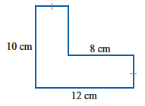 | b) | 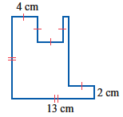

13. | [5 marks]
 | Find the shaded area.
a) | 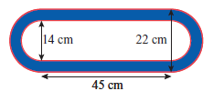

14. | [4 marks]
Cement sheeting is to be used to cover the rectangular external wall of a shed 5000mm wide and 3000mm high.
The doorway is 900mm wide and 1800mm high and the window is 1200 mm wide and 600mm high and these are not to be covered.
a) Sketch a diagram of the scenario
b) How many squares metres of cement sheeting will be on the finished wall?

~ END OF TEST SECTION 2 ~

ACE / EXTENSION QUESTIONS
15. | [2 marks]
 | Calculate the length of the unknown side.

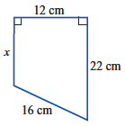

16. | [3 marks]
Find the area of the triangle XYZ
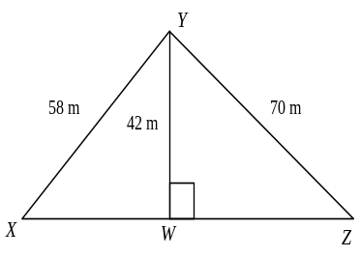

17. | [2 marks: 1, 1]
 | Calculate the area of the following sectors.
a) | b)
 | 